CASE STUDY – KIRIN USA, INC.: ICHIBAN SHIBORI

# MARKETING ANALYTICS | Abhishek Mudurakola | Shanmukh Sainath Burugupalli | Renu Deepya Iska | 03/25/2024

## Case Study Overview

* Kirin, a Japanese beer brand, aims to strengthen its position in the U.S. import beer market. To achieve this goal, Kirin needs to understand consumer preferences, competitive positioning, and market segmentation.
* The case study provides various datasets, including conjoint analysis data, positioning analysis data, and segmentation analysis data, to help Kirin gain insights into these aspects.

## Possible Questions:

### Question 1: Based on conjoint analysis, what is the best product composition for Kirin, taking into mind consumer preferences for various aspects such as origin, price, body, aftertaste, calories, packaging, and glass? Moreover, how does this suggested structure compare to competitors' current products and possible new product categories?

To determine the best product composition for Kirin based on conjoint analysis, we need to consider various aspects that influence consumer preferences, including origin, price, body, aftertaste, calories, packaging, and glass. Conjoint analysis allows us to understand how consumers make trade-offs between these attributes when making purchasing decisions. Let's break down each aspect and analyze its implications:

Origin: Conjoint analysis may reveal that consumers have preferences for beer originating from specific regions or countries known for their brewing traditions. Kirin can use this insight to highlight the authenticity and heritage of its products, potentially enhancing their perceived value.

Price: Understanding consumers' price sensitivity is crucial for pricing strategies. Conjoint analysis can identify the price range within which consumers perceive the best value for beer, allowing Kirin to set competitive yet profitable price points.

Body: Consumers may prefer beers with varying levels of body, ranging from light to full-bodied. Kirin can develop product variants catering to different preferences, ensuring that each segment finds a suitable option within its portfolio.

Aftertaste: The aftertaste of beer can significantly impact consumer satisfaction. Conjoint analysis helps identify which aftertaste profiles resonate most with consumers, guiding Kirin in formulating products with desirable flavor characteristics.

Calories: Health-conscious consumers may consider the calorie content of beer when making purchase decisions. Kirin can use conjoint analysis to determine the optimal balance between taste and calorie content, offering products that appeal to health-conscious individuals without compromising flavor.

Packaging: Packaging plays a crucial role in consumer perception and brand image. Conjoint analysis can reveal preferences for packaging materials, design elements, and convenience features, allowing Kirin to design packaging that enhances product appeal and differentiation.

Glass: The type of glassware associated with beer consumption can influence consumer perception and experience. Kirin can explore preferences for traditional glassware versus modern alternatives and incorporate this insight into product development and marketing strategies.

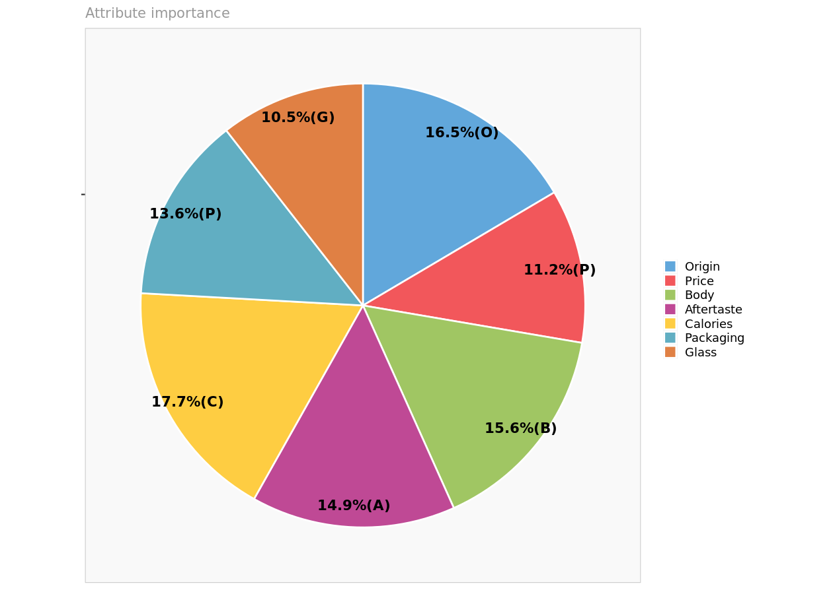

By analyzing the results of conjoint analysis across these dimensions, Kirin can identify the optimal product composition that aligns with consumer preferences and market trends. This suggested product structure should be evaluated in comparison to competitors' current offerings and potential new product categories to identify opportunities for differentiation and innovation.

For example, if conjoint analysis reveals a preference for craft beers with rich, full-bodied flavors and premium packaging among a certain segment of consumers, Kirin could introduce artisanal beer variants packaged in distinctive bottles or cans. Additionally, if there is growing demand for low-calorie options with refreshing aftertastes, Kirin could develop light beer alternatives with innovative flavor profiles and packaging formats to capture this market segment.

Combined Design:

The purpose of conjoint analysis experiments is to show participants a range of imaginary product profiles that have distinct attribute levels.

The design seeks to strike an agreement between the requirement for thorough coverage of attribute combinations and efficiency (reducing the number of profiles shown to each respondent).

To generate effective experimental designs, researchers frequently employ methods like choice-based conjoint analysis and fractional factorial designs.

Existing and New Product Profiles:

While new product profiles are prospective goods that a company, like Kirin, might introduce, existing product profiles represent current offerings in the market, frequently from competitors. Brand, taste, packaging, and pricing are just a few examples of the qualities and quantities that are important to consumers when making decisions. Conjoint analysis uses these profiles to determine consumer preferences, guide product development, and spot chances for innovation and difference. Businesses can make strategic decisions to optimize their product portfolios and maintain competitiveness by evaluating preferences for new and existing product profiles.

Overall, leveraging conjoint analysis insights allows Kirin to optimize its product portfolio, differentiate its offerings from competitors, and capitalize on emerging consumer trends, ultimately driving growth and profitability in the beer market.

### Question 3: How does conjoint analysis complement the segmentation insights provided by Enginius?

Conjoint analysis and segmentation analysis serve complementary roles in understanding consumer preferences and behavior in the market. While segmentation analysis identifies distinct groups of consumers with similar characteristics and needs, conjoint analysis delves deeper into understanding the preferences and trade-offs within these segments. Here's how conjoint analysis complements the segmentation insights provided by Enginius:

Fine-grained Understanding: Segmentation analysis identifies broad segments of consumers based on similarities in demographics, behaviors, or preferences. Conjoint analysis, on the other hand, provides a more nuanced understanding of consumer preferences by examining trade-offs between specific product attributes within each segment. It helps uncover which product features are most valued by different consumer groups, allowing for tailored product development and marketing strategies.

Segment-specific Product Preferences: Conjoint analysis can reveal segment-specific product preferences that may not be apparent from segmentation analysis alone. By analyzing preferences for various product attributes across different segments, companies like Kirin can identify unique opportunities to tailor their offerings to meet the distinct needs and preferences of each segment effectively.

Optimal Product Positioning: Conjoint analysis helps determine the optimal positioning of products within each segment based on consumers' preferences for different product attributes. By understanding which attributes drive purchase decisions within each segment, companies can develop targeted marketing messages and product positioning strategies that resonate with their target audience.

Portfolio Optimization: Conjoint analysis provides valuable insights for optimizing product portfolios within each segment. It helps identify the most desirable product features and configurations, guiding decisions related to product development, pricing, and packaging. This ensures that companies like Kirin can offer a diverse range of products that cater to the preferences of each segment while maximizing profitability and market share.

Competitive Benchmarking: Conjoint analysis can also be used for competitive benchmarking, allowing companies to compare their products' perceived value against competitors' offerings. By understanding how consumers evaluate different products in the market based on their attributes, companies can identify opportunities for differentiation and innovation to gain a competitive edge within their target segments.

Overall, conjoint analysis complements segmentation insights by providing a deeper understanding of consumer preferences within each segment, guiding product development, positioning, and competitive strategy decisions. By combining the two approaches, companies can develop more targeted and effective marketing strategies that resonate with their target audience and drive business growth.

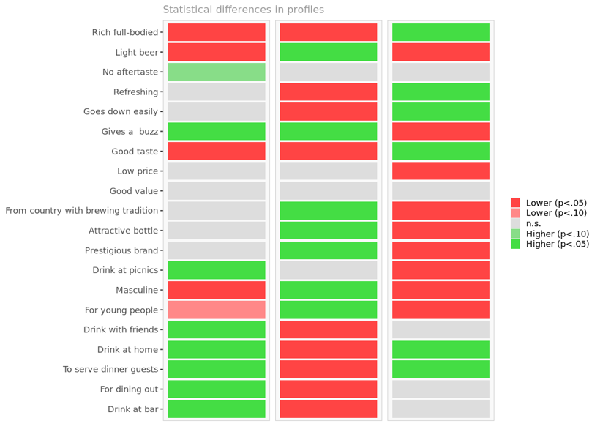 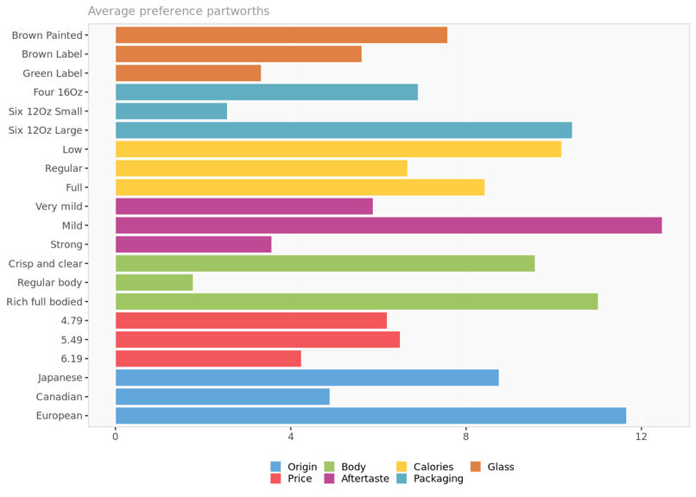

### Question 3: How can positioning analysis enhance the understanding of customer segments identified through Enginius?

Positioning analysis plays a crucial role in enhancing the understanding of customer segments identified through Enginius by providing insights into how to effectively position products or brands to resonate with each segment's preferences and needs. Here's a detailed explanation:

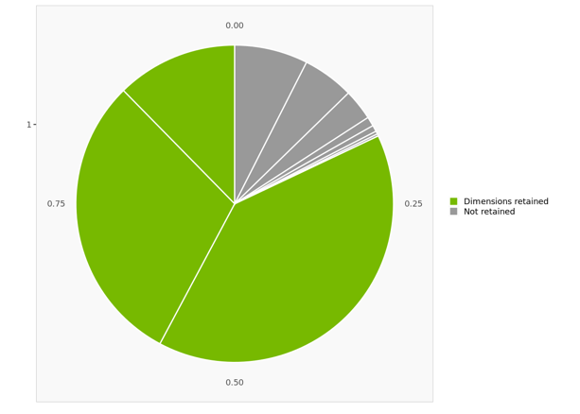

|  |  |  |  |
| --- | --- | --- | --- |
|  | **Dimension I** | **Dimension II** | **Dimension III** |
| **1 Most positive** | Drink with friends | Light | Good value for money |
| **2** | Drink at bar | No aftertaste | Lower price |
| **3** | Good taste | Drink at picnics and outings |  |
| **4** | For home after work |  |  |
| **5** | To serve guests at home |  |  |
| **6** | Rich full-bodied taste |  |  |
| **7** | Country with brewing tradition |  |  |
| **8 ...** |  |  |  |
| **9 Most negative** |  | Masculine | For young people |

**Dimension interpretation**. Displays the names of the attributes most aligned with each dimension.

Identifying Unique Value Propositions (UVPs): Positioning analysis helps uncover the unique value propositions that appeal most to each customer segment. By analyzing market data, competitor positioning, and customer preferences, businesses can identify the specific features, benefits, or attributes that differentiate their offerings in the eyes of different segments. This understanding allows companies to tailor their messaging and marketing strategies to highlight these UVPs effectively.

Segment-specific Messaging and Communication Strategies: Through positioning analysis, businesses can develop segment-specific messaging and communication strategies that resonate with the preferences, values, and aspirations of each customer segment. By understanding the language, imagery, and channels preferred by different segments, companies can craft targeted marketing campaigns that speak directly to the needs and desires of each group, increasing the effectiveness of their messaging and driving engagement.

Product and Brand Differentiation: Positioning analysis helps businesses identify opportunities for product and brand differentiation within each segment. By evaluating factors such as product features, pricing strategies, packaging design, and brand messaging, companies can identify areas where they can differentiate their offerings to better meet the unique needs and preferences of each segment. This differentiation not only helps attract customers but also fosters loyalty and reduces the threat of competitive substitutes.

Addressing Unmet Needs and Pain Points: Positioning analysis allows businesses to identify unmet needs and pain points within each segment and develop products or services that address these gaps effectively. By understanding the specific challenges, frustrations, or barriers faced by different segments, companies can innovate and tailor their offerings to provide solutions that meet customers' needs more comprehensively. This customer-centric approach not only drives customer satisfaction but also strengthens brand loyalty and advocacy.

Optimizing Product Positioning and Portfolio Strategy: By combining the insights from Enginius segmentation analysis with positioning analysis, businesses can optimize their product positioning and portfolio strategy to maximize market penetration and profitability. This involves identifying the most attractive market segments for each product or brand, determining the optimal positioning strategy within each segment, and aligning the product portfolio to cater to diverse customer preferences effectively. Through strategic product positioning, businesses can capture market share, increase customer loyalty, and drive sustainable growth.

In summary, positioning analysis enhances the understanding of customer segments identified through Enginius by providing insights into unique value propositions, segment-specific messaging, product differentiation, addressing unmet needs, and optimizing product positioning and portfolio strategy. By leveraging positioning analysis alongside segmentation insights, businesses can develop targeted marketing strategies, drive product innovation, and strengthen their competitive advantage in the marketplace.

### Question 4: How can Kirin effectively implement the formulated marketing and product strategies derived from the analysis to enhance its position in the competitive U.S. import beer market, and what measures should be taken to monitor the effectiveness of these strategies while remaining agile in response to evolving consumer preferences and market dynamics?

Implementing the formulated marketing and product strategies derived from the analysis to enhance Kirin's position in the competitive U.S. import beer market requires a comprehensive approach and ongoing monitoring. Here's a detailed plan:

Product Strategy Implementation:

Product Portfolio Optimization: Based on the segmentation insights and conjoint analysis, Kirin should refine its product portfolio to align with the preferences of different consumer segments. This may involve adjusting existing products or introducing new ones tailored to specific segment preferences, such as flavor profiles, packaging options, and pricing tiers.

Positioning and Branding: Develop clear positioning statements and branding strategies for each product line or variant to resonate with target segments. Highlight unique selling propositions (USPs) that differentiate Kirin's offerings from competitors and appeal to the identified consumer preferences.

Packaging and Labeling: Enhance packaging designs and labeling to communicate the brand's value proposition effectively. Consider incorporating elements that evoke the desired brand image and convey quality, authenticity, and alignment with consumer lifestyles and preferences.

Marketing Strategy Implementation:

Targeted Marketing Campaigns: Develop targeted marketing campaigns tailored to each consumer segment identified through Enginius. Utilize channels and messaging that resonate with the demographics, psychographics, and behaviors of each segment. Leverage digital marketing platforms, social media, influencer partnerships, and experiential marketing initiatives to reach and engage target consumers effectively.

Promotional Activities: Implement promotional activities, discounts, and incentives to encourage trial and purchase among target segments. Leverage consumer insights to design promotions that appeal to specific segment preferences and purchase motivations, such as limited-time offers, loyalty programs, and cross-promotions with complementary products or experiences.

Brand Activation Events: Host brand activation events, tastings, and experiential activations to increase brand visibility, generate buzz, and foster consumer engagement. Create memorable brand experiences that reinforce Kirin's positioning and values while providing opportunities for consumers to interact with the products firsthand.

Monitoring and Agility Measures:

Performance Metrics: Establish key performance indicators (KPIs) to measure the effectiveness of the implemented strategies, such as sales volume, market share, brand awareness, consumer sentiment, and customer lifetime value. Regularly track and analyze these metrics to assess the impact of the strategies on business outcomes and identify areas for optimization.

Consumer Feedback and Market Research: Continuously gather consumer feedback through surveys, focus groups, and social listening to understand evolving preferences, perceptions, and behaviors. Conduct market research to monitor industry trends, competitive activities, and emerging opportunities or threats. Use these insights to refine strategies in real time and stay responsive to changing market dynamics.

Agile Strategy Iteration: Maintain agility in strategy execution by adopting iterative and adaptive approaches. Be prepared to pivot quickly based on performance data, consumer feedback, and market trends. Test and refine different tactics, messaging, and product variations to optimize outcomes and capitalize on emerging opportunities while mitigating risks.

By implementing these strategies and monitoring their effectiveness while remaining agile in response to evolving consumer preferences and market dynamics, Kirin can enhance its position in the competitive U.S. import beer market and drive sustainable growth and profitability.

### Question 5: How might Kirin use analytics to measure the effectiveness of its marketing campaigns targeted at different segments identified by Enginius?

To effectively measure the effectiveness of its marketing campaigns targeted at different segments identified by Enginius, Kirin can employ various analytics techniques and metrics. Here's a detailed explanation along with visual representations:

Segment-specific Key Performance Indicators (KPIs):

Kirin can define segment specific KPIs to evaluate the success of its marketing campaigns. These KPIs should align with the objectives set for each segment. For example, KPIs could include changes in brand awareness, customer engagement, purchase intent, and market share within each segment.

Customer Journey Analysis:

Analyzing the customer journey for each segment can provide insights into how effectively marketing campaigns are driving conversions and engagement at different touchpoints. Kirin can use techniques like attribution modeling to understand the contribution of each marketing channel to conversions within each segment.

Segment-specific Return on Investment (ROI) Analysis:

Kirin can conduct ROI analysis to evaluate the profitability of marketing campaigns for each segment. By comparing the costs incurred with the generated revenues and customer lifetime value (CLV) within each segment, Kirin can assess the efficiency of its marketing spend.

Sentiment Analysis and Social Listening:

Monitoring social media channels and online forums for mentions and sentiment related to Kirin's brand and products can provide real-time feedback on the effectiveness of marketing campaigns. Sentiment analysis tools can help identify positive and negative sentiments expressed by customers within each segment.

A/B Testing and Experimentation:

Kirin can conduct A/B tests and experiments to compare the performance of different marketing strategies and messaging variations across segments. By randomly assigning segments to different treatment groups, Kirin can measure the impact of changes in marketing tactics on key metrics.

By leveraging these analytics approaches and visual representations, Kirin can gain actionable insights into the effectiveness of its marketing campaigns targeted at different segments identified by Enginius. This data-driven approach enables Kirin to make informed decisions, optimize marketing spend, and enhance its competitive position in the U.S. import beer market.